Determining Human History from Fossil Evidence
PROBLEM
How can we learn about human history? Fossil remains provide a record of early humans and other primates (lemurs, monkeys, and apes). By studying primate fossils, anthropologists attempt to trace the beginnings of humans. Although humans and other primates have many similarities, humans did not evolve from apes. But the evidence does point to a common ancestor for all primates.

OBJECTIVES
- To compare the physical differences between types of primate hands
- To measure and evaluate drawings of primate skulls and teeth
- To simulate the task of anthropologists in identifying fossil remains

MATERIALS
- protractor
- metric ruler

PROCEDURE
Part I. Analysis
- Examine the four kinds of primate hands drawn below. Look for similarities and differences. The evolution of hands and the ability to use hands (manipulation) is believed to be linked with the development of the brain. Answer questions #1-5 below.
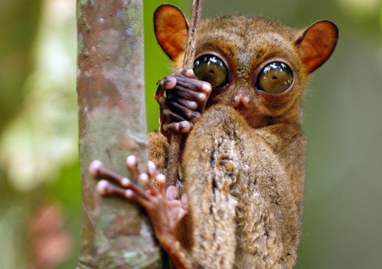 | 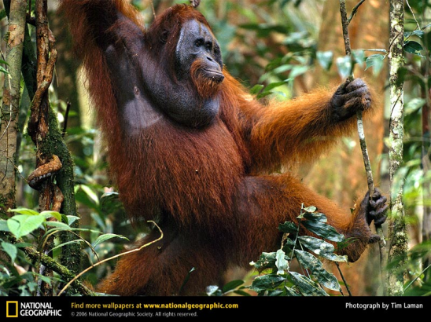 | 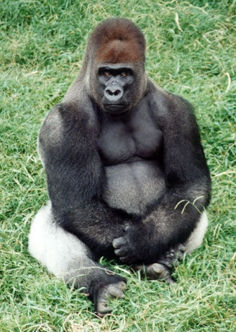
Tarsier | Orangutan | Gorilla

- What do the primates’ hands have in common (list three):
a.
b.
c.
2. The tarsier and orangutan are experts at swinging from tree to tree. What hand features help them in their acrobatics?
3. In what way is the gorilla’s hand different from that of other primates?
4. The gorilla’s hand is used for walking and grasping. How is its hand well adapted for both activities?
5. In what way is the human’s hand the most highly developed?

PART II. Investigation
The excitement of actually discovering and holding an ancient primate fossil cannot be duplicated in the lab. But the identification process can be simulated.

Examine the three primate skulls (X, Y, and Z) on the next page. Imagine yourself an anthropologist. These skull specimens (probably in many pieces) are placed before you for the purpose of identifying them. How would you proceed?

First, fit the pieces of the skull together (the artist has done that already), and then take careful measurements of specific areas. These measurements can be compared with the basic knowledge of primate fossils to help you reach a conclusion. Begin by taking measurements as explained below. Copy the Data Sheet Table in your lab notebook and record your findings. Compare your results with the fact sheet (at the bottom of this page) and then identify each skull as that of a gorilla, a humanoid or a modern human – Homo sapiens. Complete your primate study by measuring the hip bones and counting the types of teeth illustrated on the next page. Record these findings in the Data Sheet Table. Answer questions 6-10.

BRAIN CAPACITY: The circle drawn on each skull represents the brain capacity of each primate. Measure the diameter of each circle and multiply it by 200 to approximate the brain capacity in cubic centimeters. Record the figures for X, Y, and Z in the Data Sheet Table.
LOWER FACE AREA: Measure the skulls of each figure: a to b and c to d. Determine the area of the lower face by multiplying these numbers together.
BRAIN AREA: Find the area of the brain by measuring the length and width, from e to f and g to h, and multiplying the two figures together.
JAW ANGLE: Note the two lines in the nose area of each skull. Measure the outside angle with your protractor. This measurement will indicate how far the jaw projects outward, also called prognathism.
SAGITTAL CREST: This is the bony ridge on the top of the skull. Indicate in the Table whether it is present or absent in each skull.
BROW RIDGE: This is the bony ridge above the eye socket. Indicate its presence or absence in the Table.
TEETH: In the Table, indicate the number of teeth in the lower jaw (mandible), and the number of each kind of tooth. See the drawing on the following page.
HIPS: Note the size of the hip bones shown in the side views on the next page. Does the flange, or lower portion, of the hip bone project to the rear? Indicate the relative size (small, medium, large) and direction (straight, slanted back 25°, slanted back 45°) of the flanges in the Table.

FACTS
1. A large brain capacity is characteristic of Homo sapiens (modern humans).
2. Less face area and more brain area is typical of Homo sapiens (modern humans).
3. A jaw angle of approximately 90° is a trait of Homo sapiens (modern humans).
4. The sagittal crest is related to muscles used to move the lower jaws. As the lower jaw became smaller in more complex organisms, the size of this ridge decreased.
5. Modern humans have lost the characteristic of having a brow ridge. However, it is more prominent in males than females.
6. All primates have the same number of teeth. They also have the same number of each kind of tooth.
7. The smaller hip bones with a proportionately broader blade and with flange projecting to the rear are traits found in upright primates.

Data
Measure and examine the fossil remains as described in your Procedure page. Evaluate your findings by consulting the facts above. Record your measurements and observations in your data table.

Comparison of Primate Fossil Remains
TRAIT | X | Y | Z
Brain Capacity
Lower Face Area
Brain Area
Jaw Angle
Sagittal Crest
Brow Ridge
Teeth: Number
Kinds of Teeth (and number of each kind)
Hip Size and
Direction of Flange

Analysis Questions
1. Describe the differences in brain capacity of X, Y, and Z.
2. Which traits are similar in all three primates?
3. What primate has the most reduced face area compared to its brain area?
4. Which primate(s) do you think stand upright?
5. On the basis of your measurements, observations, and information, identify the fossil remains as modern human, a human ancestor (humanoid), or gorilla.

X __________________ Y__________________ Z__________________

6. What traits are similar in Y and Z?
7. How do the jaw-angle measurements differ among the primates?
8. How do the brain and face area measurements vary?
9. Which trait helped you to identify a modern human?
10. What do you notice about the dental patterns among the three samples? What does this tell you about primates?

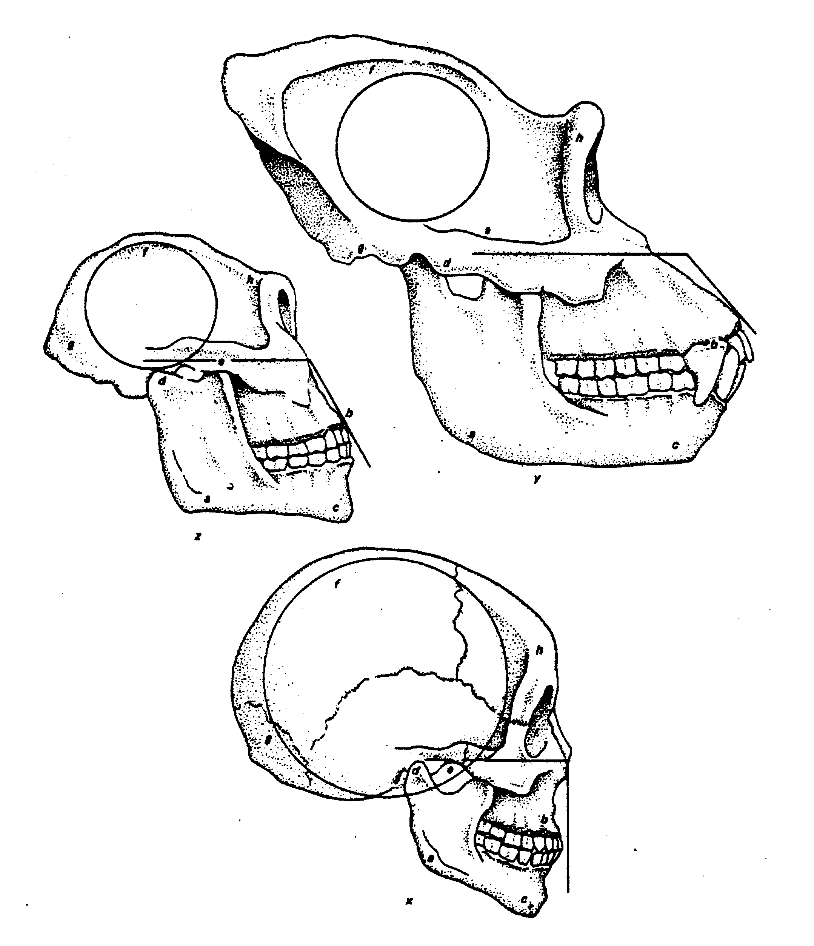

Name___________________________________ Date________________ Hour ____

